**Curriculum Vitae**

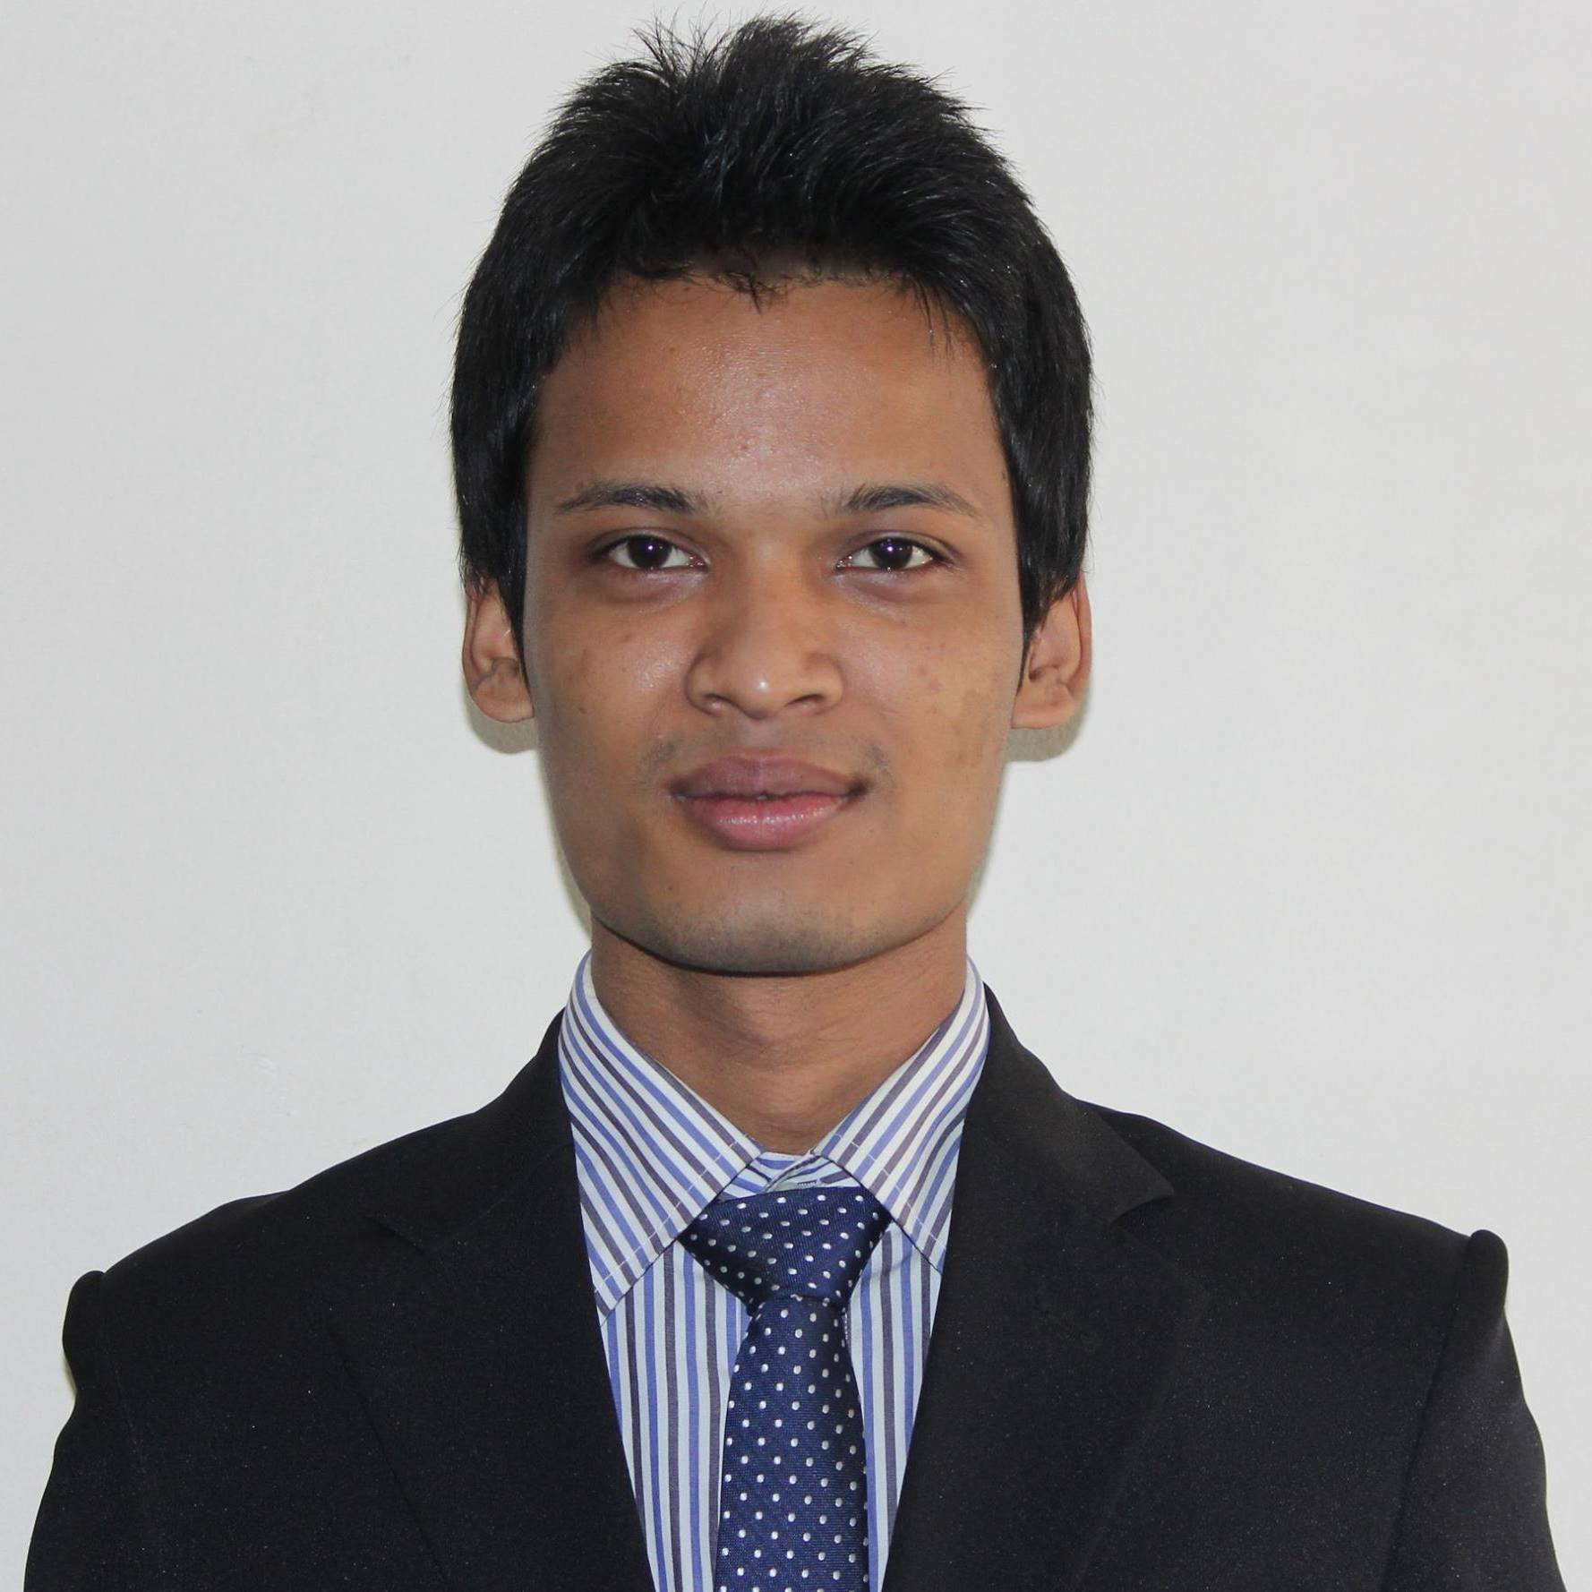

**Sanjay Roy**

*Cell: +8801738267451*

E-mail: lipuroy.law365@gmail.com

**Career Objective**

To prove myself as a quick learner and highly energetic person to face any challenge and to build up my career in such a responsible administrative position at a well-structured organization and successfully apply acquired managerial and skills to enhance organizational efficiencies.

**Key Qualities**

* Hard working with honesty and simplicity.
* Flexible, able to work independently or as a team member.
* Strong, logical and quick learning capabilities.
* Good presentation skill & strong desires to achieve results.
* Ability to take responsibility and work under pressure.

**Academic Background**

**LL.B (Hon’s.)**

Bangladesh University of Business and Technology (BUBT)

Passing Year: 2017

CGPA: 2.67*(Out of 4)*

Session: 2012-2013

**Higher Secondary School Certificate (H.S.C.)**

Group : Commerce

Result : B grade (*G.P.A: 3.20 on a scale of 5.00*)

Passing Year : 2012

Institution : Dinajpur Adarsha College

Board : Dinajpur

**Secondary School Certificate (S.S.C)**

Group : Science

Result : A grade (*G.P.A: 4.31 on a scale of 5.00*)

Passing Year : 2009

Institution : Chirirbandar Pilot High School

Board : Dinajpur

**Certification Course**

1. Income tax and corporate practice

Time duration: Eight weeks

Year: 2017

2. Estate law

Time duration: Eight weeks

Year: 2017

**Skills**

**Communication Skills**

* Fluent in Bengali and English- both verbal and written.
* Proficient in writing and editing reports and dealing with multimedia presentation.

**Computer Skills**

* Operating System :Windows 7, Windows 8.1 , Windows 10
* Office Application :MS word, MS Excel, MS Power point
* Graphics Software :Adobe Photoshop
* Internet :Browsing, Communication
* Typing Speed :Good typing speed in both Bengali &English

**Organizational Skills**

* Member, BUBT Sports Club
* Member, BUBT photography club
* Member, BUBT Cultural Club
* Member, BUBT Lawyers Association (BULA)

**Hobbies**

* Photography and Traveling.

**Personal Details**

* Name : Sanjay Roy
* Father’s Name : Mukundu Roy
* Mother’s Name : Daya Rani Roy
* Permanent Address : Village : Gobindapur, Post Office : Manmathapur   
   Police Station: Parbatipur, District: Dinajpur
* Date of Birth : 24 February ,1995
* Nationality : Bangladeshi by birth
* Religion : Hindu
* Marital Status : Single
* Sex : Male
* Blood Group : B+
* Height : 5’10’’
* Weight : 64 kg
* National ID No. : 19952717760000091

**References**

1. **Ashraful Alam Khan**

Law Officer

Legal & Compliance Department BRAC

Cell: +8801911777027

E-mail: ashraful.bubt@gmail.com

**2. Md. Mustafizur Rahman**

Assistant Consultant

EQMS Consulting Limited

Cell: +8801734128665

E-mail: m.rahman@eqmsbd.com

**Certification**

I certify that all information stated in this resume is true and complete to the best of my knowledge. I authorize you to verify the information provided in this resume.



Signature

Date: 23/09/2017